YUVA INTERN
INTERNSHIP REPORT
Week 2 Task: Exploratory Data Analysis and Visualization
Domain: Data Science
Dataset: Airbnb Open Data (New York City) — Cleaned in Week 1
Internship Duration: 6 Weeks
Submitted by:
Aman Yadav
Deen Dayal Upadhyay Gorakhpur University
Submission Date: 14 September, 2026

Table of Contents
Title Page No.
Table of Contents 2-3
Acknowledgement 4
- Introduction 5
- About the Internship Program 5
- Objective of the Task 5
- Scope of the Report 5
- About the Dataset 6
- Tools and Technologies Used 7
- Methodology 8
- Step 1 — Loading and Re-Validating the Cleaned Dataset 8
- Step 2 — Identifying Residual Data Quality Issues 8
- Step 3 — Transformations Applied for Analysis 9
- Step 4 — Statistical Summarization 9
- Step 5 — Categorical Variable Analysis 10
- Visualizations and Interpretation 12
- Room Type Distribution 12
- Neighbourhood Group Distribution 12
- Price Distribution 13
- Price Distribution by Room Type 13
- Average Price by Room Type and Neighbourhood Group 14
- Minimum Nights and Number of Reviews Distributions 14
- Price vs. Number of Reviews 15
- Correlation Matrix of Numerical Variables 15
- Cancellation Policy Analysis 16
- Group-Wise Summary Analysis 17
- Summary by Room Type 17
- Summary by Neighbourhood Group 17
- Average Price by Room Type × Neighbourhood Group (Pivot Table) 18
- Key Insights 19
- Challenges Faced and How They Were Overcome 20
- Currency-Formatted Service Fee Field 20
- Logically Invalid Negative Values 20
- Residual Categorical Typo 20
- Right-Skewed Distributions Affecting Visualization Clarity 20
- Weak Correlations Complicating Insight Generation 21
- Conclusion 22
- Key Learnings 22
- Key Learnings 22
- Future Scope 22
- References 23

ACKNOWLEDGEMENT
I would like to express my sincere gratitude to Yuva Intern and the National Skill Development Corporation (NSDC) for the opportunity to work on this Exploratory Data Analysis task as part of Week 2 of my internship. This task allowed me to build directly on the cleaned dataset produced in Week 1 and deepen my practical understanding of data analysis and visualization using Python.
I am grateful to my mentors and the internship coordination team for their structured task guidance and continued support, which helped me approach this analysis systematically and interpret the results meaningfully.
I also thank my family, friends, and peers for their constant encouragement throughout this learning journey.

Introduction
- About the Internship Program
Yuva Intern, in association with the National Skill Development Corporation (NSDC), conducts a structured 6-week internship program in Data Science and Analytics. Week 1 of the program focused on acquiring and cleaning a real-world dataset; Week 2 builds directly on that foundation by requiring Exploratory Data Analysis (EDA) and visualization of the cleaned dataset to extract meaningful insights.
This report documents the work completed for the Week 2 task, titled “Exploratory Data Analysis and Visualization.” The objective was to analyze the cleaned Airbnb dataset produced in Week 1 using Python libraries such as pandas, Matplotlib, and Seaborn, summarize key statistics, and create annotated visualizations that reveal trends, patterns, and relationships within the data.
- Objective of the Task
“Perform exploratory data analysis (EDA) and visualization on a public dataset to extract meaningful insights using Python libraries such as Pandas, Matplotlib, and Seaborn. Document the analysis approach, summarize key findings, and create properly annotated visualizations that highlight trends and patterns.”
To fulfil this objective, the dataset cleaned during Week 1 (Cleaned_Data.csv, 99,342 records) was loaded, further quality-checked, lightly transformed where necessary, and explored through univariate, bivariate, and correlation analysis, supported by twelve annotated visualizations.
- Scope of the Report
Loading and re-validating the Week 1 cleaned dataset
Identifying residual data quality issues specific to analysis (formatting, invalid values, category typos)
Statistical summarization of numerical and categorical variables
Univariate visualizations of room type, neighbourhood group, price, minimum nights, and reviews
Bivariate visualizations examining price against room type, neighbourhood group, and cancellation policy
Correlation analysis among numerical variables
Group-wise summary statistics and pivot-table analysis
Key insights, challenges encountered, and conclusions drawn from the analysis

About the Dataset
The dataset used for this task is the output of the Week 1 data cleaning task: Cleaned_Data.csv. It contains listing-level information for Airbnb properties across New York City, already free of duplicate rows and missing values, but requiring some further quality checks specific to this stage of analysis.
Property | Details
Input file | Cleaned_Data.csv (Week 1 output)
Records loaded | 99,342
Columns loaded | 20
Output file | Airbnb_EDA_Final.csv
Final records (post-EDA cleaning) | 99,330
Granularity | One row per Airbnb listing

Core variables used throughout the analysis include the categorical fields room type, neighbourhood group, cancellation_policy, host_identity_verified, and instant_bookable, and the numerical fields price, service fee, minimum nights, and number of reviews.

Tools and Technologies Used
Tool / Library | Purpose
Python 3 | Core programming language used for the analysis
Jupyter Notebook | Interactive environment for iterative EDA and visualization
pandas | Data loading, transformation, grouping, and statistical summarization
NumPy | Underlying numerical operations supporting pandas
Matplotlib | Base plotting engine for charts and figure control
Seaborn | Statistical visualizations (count plots, histograms, box plots, heatmaps)
Seaborn was used alongside Matplotlib because it provides high-level, statistically-aware plotting functions (such as countplot, histplot, boxplot, and heatmap) that integrate directly with pandas DataFrames, making it well suited to rapidly producing consistent, publication-quality visualizations during exploratory analysis.

Methodology
- Step 1 — Loading and Re-Validating the Cleaned Dataset
The Week 1 output was loaded and re-validated to confirm it was still complete and duplicate-free before analysis began.
import pandas as pd
import numpy as np
import matplotlib.pyplot as plt
import seaborn as sns

df = pd.read_csv("Cleaned_Data.csv")
print("Number of rows:", df.shape[0]) # 99342
print("Number of columns:", df.shape[1]) # 20
print("Duplicate rows:", df.duplicated().sum()) # 0
df.info() and df.isnull().sum() confirmed zero missing values across all 20 columns, validating that the Week 1 cleaning process had produced a fully complete dataset ready for exploratory analysis.
- Step 2 — Identifying Residual Data Quality Issues
Although the dataset had no missing values, closer inspection for the purposes of numerical analysis revealed three additional issues that had not been addressed in Week 1:
The service fee column was still stored as text with a "$" symbol (e.g., "$193 "), preventing numeric aggregation.
The minimum nights column contained 12 negative values, ranging down to −1223 nights, which are logically invalid for a booking duration.
The neighbourhood group column contained one residual misspelled category, "brookln", alongside the correctly spelled "Brooklyn".
df['service fee'].unique()[:5] # array(['$193 ', '$28 ', '$41 ', '$115 ', '$212 '], dtype=object)
print("Minimum value:", df['minimum nights'].min()) # -1223.0
print("Maximum value:", df['minimum nights'].max()) # 5645.0
print("Negative values:", (df['minimum nights'] < 0).sum()) # 12
print(df['neighbourhood group'].value_counts())
# Manhattan 42396, Brooklyn 40530, Queens 12867,
# Bronx 2628, Staten Island 920, brookln 1
- Step 3 — Transformations Applied for Analysis
A working copy (eda_df) was created from the cleaned DataFrame so that the original Week 1 output remained unmodified. Three targeted corrections were then applied:
eda_df = df.copy()

# 1. Convert service fee to numeric
eda_df['service fee'] = (
eda_df['service fee']
.str.replace('$', '', regex=False)
.str.strip()
.astype(float)
)

# 2. Remove rows with invalid (negative) minimum nights
eda_df = eda_df[eda_df['minimum nights'] >= 0].copy()

# 3. Correct the 'brookln' category typo
eda_df['neighbourhood group'] = (
eda_df['neighbourhood group'].replace({'brookln': 'Brooklyn'})
)
After these transformations, the working dataset contained 99,330 rows (12 fewer than the Week 1 output, due to the removal of invalid negative minimum-nights entries), zero missing values, zero duplicate rows, and a fully numeric service fee column, confirmed as follows:
print("Rows:", eda_df.shape[0]) # 99330
print("Missing values:", eda_df.isnull().sum().sum()) # 0
print("Duplicate rows:", eda_df.duplicated().sum()) # 0
- Step 4 — Statistical Summarization
Descriptive statistics were computed for the four core numerical variables: price, service fee, minimum nights, and number of reviews.
Metric | Price (USD) | Service Fee (USD) | Minimum Nights | Number of Reviews
Mean | 625.47 | 125.09 | 8.09 | 27.37
Median | 624.00 | 125.00 | 3.00 | 7.00
Minimum | 50 | — | 1 | —
Maximum | 1,200 | — | 5,645 | —

The large gap between the mean (8.09) and median (3.00) for minimum nights indicates a right-skewed distribution driven by a small number of listings requiring extended minimum stays (up to 5,645 nights), while the price variable's mean and median are very close (625.47 vs. 624.00), indicating a fairly symmetric distribution.
- Step 5 — Categorical Variable Analysis
Frequency and percentage breakdowns were computed for the key categorical variables to understand the composition of the listing base.
Room Type | Listings | % of Total
Entire home/apt | 52,047 | 52.40%
Private room | 45,018 | 45.32%
Shared room | 2,157 | 2.17%
Hotel room | 108 | 0.11%

Neighbourhood Group | Listings | % of Total
Manhattan | 42,391 | 42.68%
Brooklyn | 40,525 | 40.80%
Queens | 12,867 | 12.95%
Bronx | 2,627 | 2.64%
Staten Island | 920 | 0.93%

The dataset is also close to evenly split on binary attributes: cancellation policy is nearly balanced across moderate (33.49%), strict (33.30%), and flexible (33.21%); host_identity_verified is nearly 50/50 between UNCONFIRMED (50.04%) and VERIFIED (49.96%); and instant_bookable is similarly balanced between not-instant (50.21%) and instant (49.79%).

Visualizations and Interpretation
Twelve annotated visualizations were created using Matplotlib and Seaborn to examine univariate distributions, bivariate relationships, and correlations among numerical variables. Each is presented below with its interpretation.
- Room Type Distribution
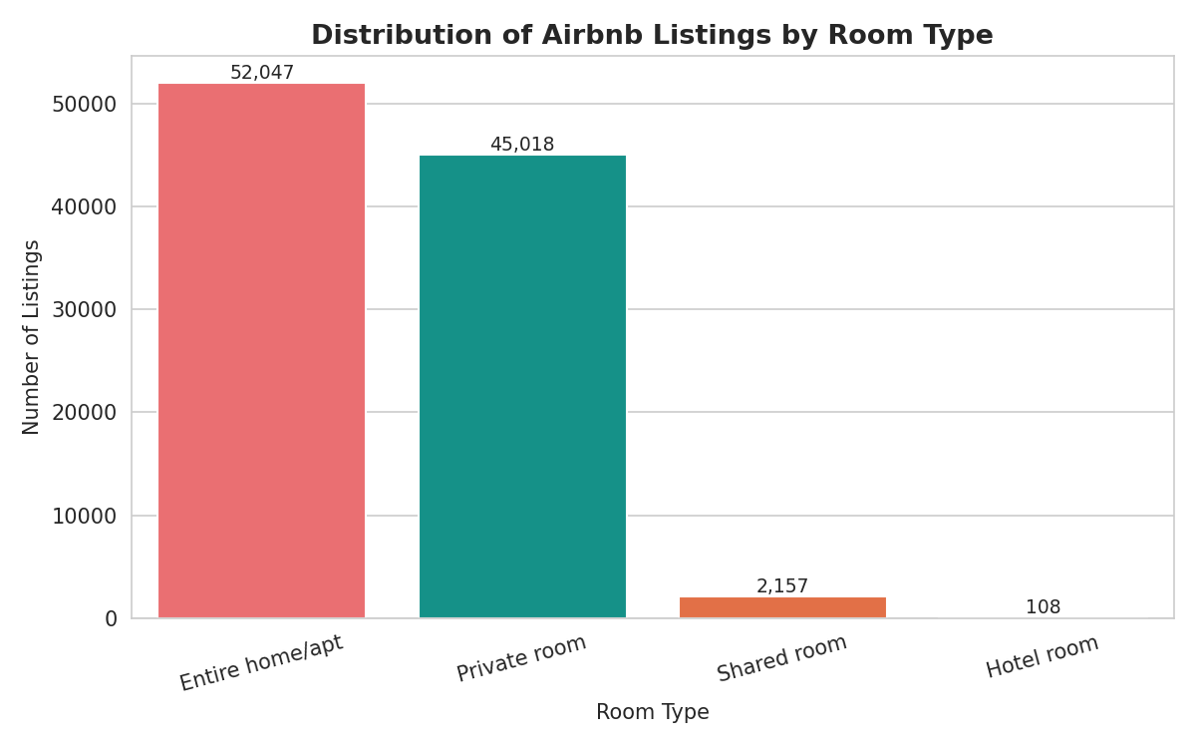
Figure 1: Distribution of Airbnb listings by room type
Entire home/apartment listings (52.40%) and private rooms (45.32%) dominate the market, together accounting for over 97% of all listings, while shared rooms and hotel rooms are a small niche segment.
- Neighbourhood Group Distribution
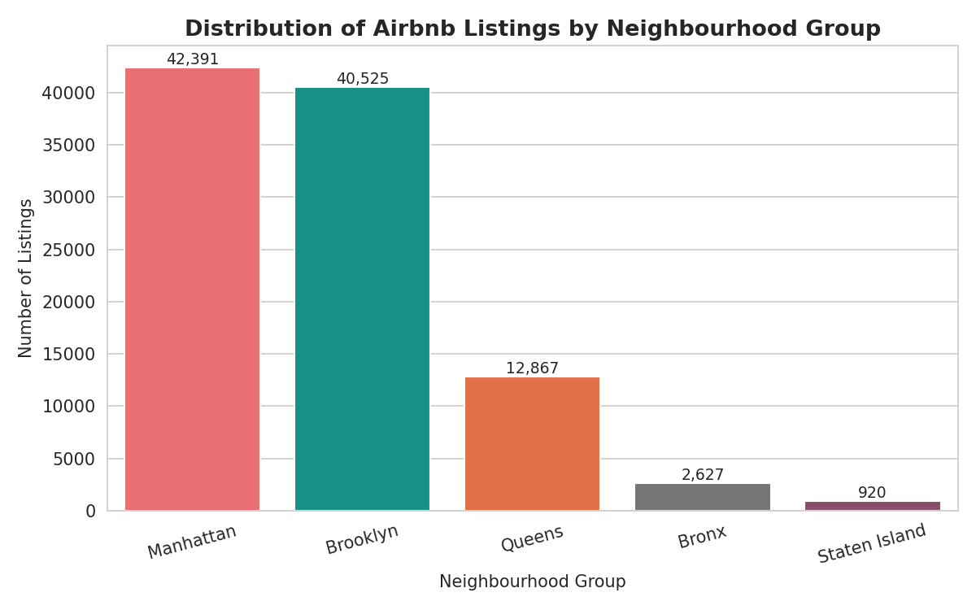
Figure 2: Distribution of Airbnb listings by neighbourhood group
Manhattan and Brooklyn together host over 83% of all listings, reflecting their status as the most in-demand boroughs for short-term rentals, while Staten Island accounts for less than 1% of listings.
- Price Distribution
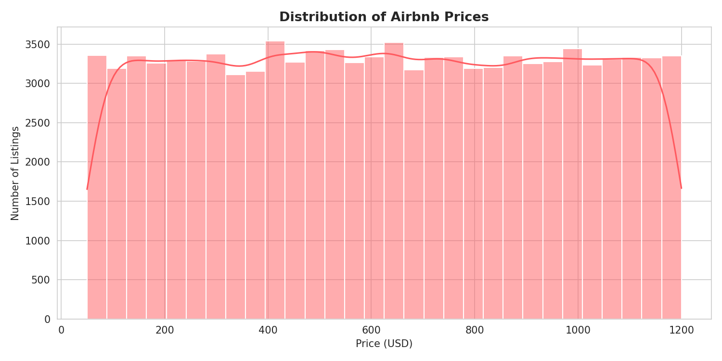
Figure 3: Distribution of Airbnb listing prices
Prices are spread relatively evenly across the $50–$1,200 range with a slight concentration around the mean (~$625), rather than showing the steep right-skew typically seen in real-world Airbnb pricing data, suggesting prices in this dataset were assigned close to uniformly.
- Price Distribution by Room Type
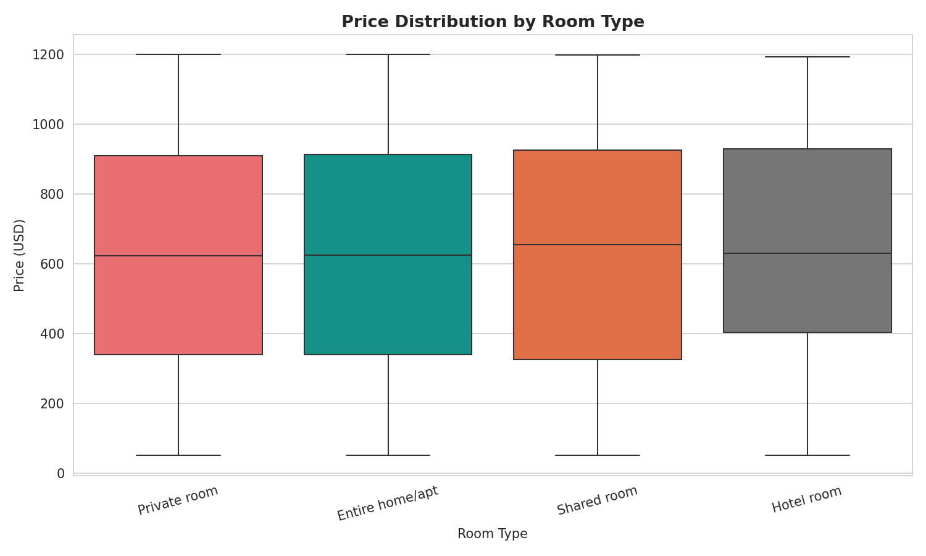
Figure 4: Boxplot of price distribution across room types
Median prices are broadly similar across room types, but hotel rooms and shared rooms show a wider interquartile spread, and hotel rooms have the highest average price (~$658) despite having only 108 listings.
- Average Price by Room Type and Neighbourhood Group
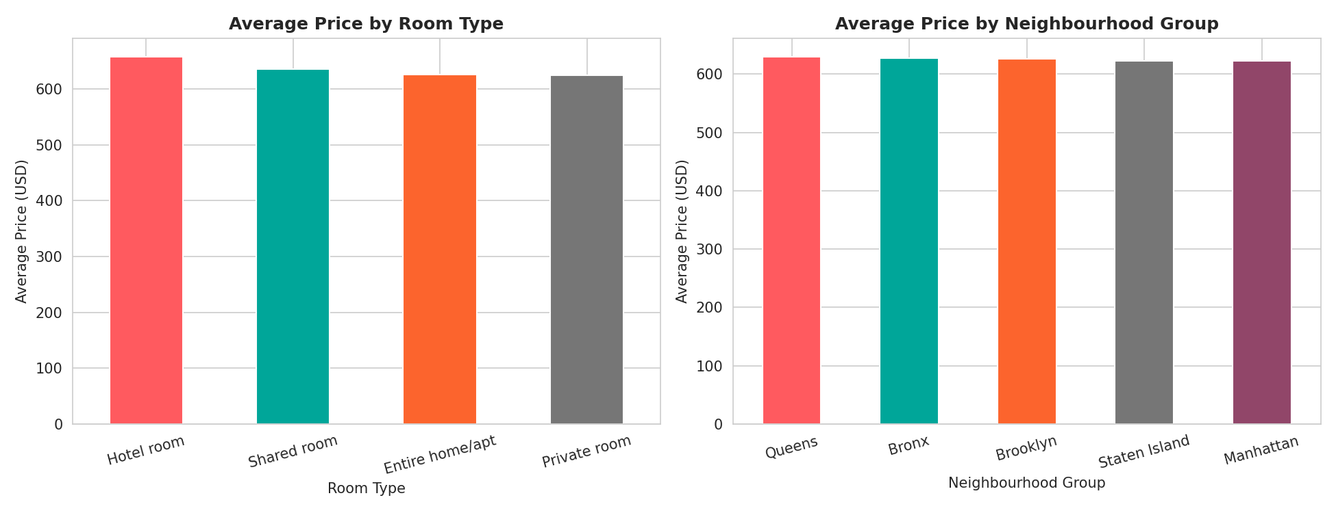
Figure 5: Average price by room type (left) and by neighbourhood group (right)
Average price varies only modestly across categories, ranging narrowly from about $620 to $658 across room types, and from about $623 to $630 across boroughs — indicating that neither room type nor location is a strong standalone driver of price in this dataset.
- Minimum Nights and Number of Reviews Distributions
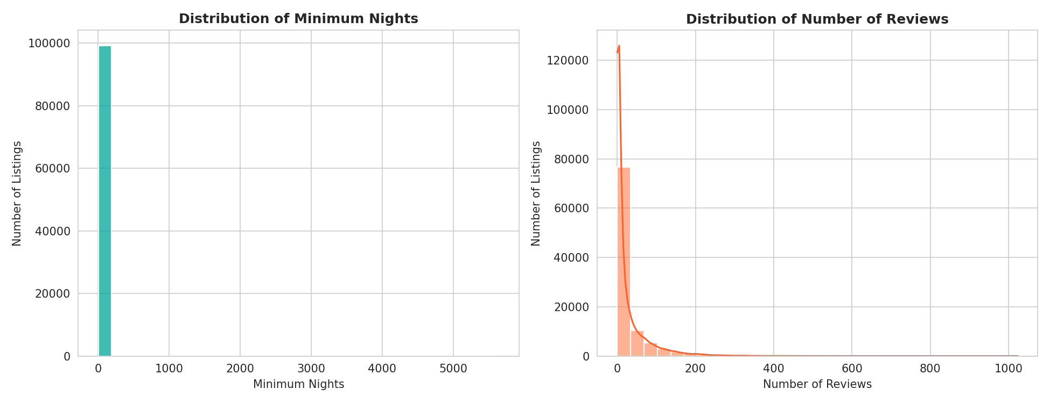
Figure 6: Distribution of minimum nights (left) and number of reviews (right)
The minimum nights distribution is heavily right-skewed, with the vast majority of listings requiring fewer than 30 nights, but a long tail of outliers extending to 5,645 nights pulling the mean well above the median. The number of reviews is similarly right-skewed, with most listings having relatively few reviews and a small number of highly-reviewed listings driving the mean (27.37) far above the median (7.00).
- Price vs. Number of Reviews
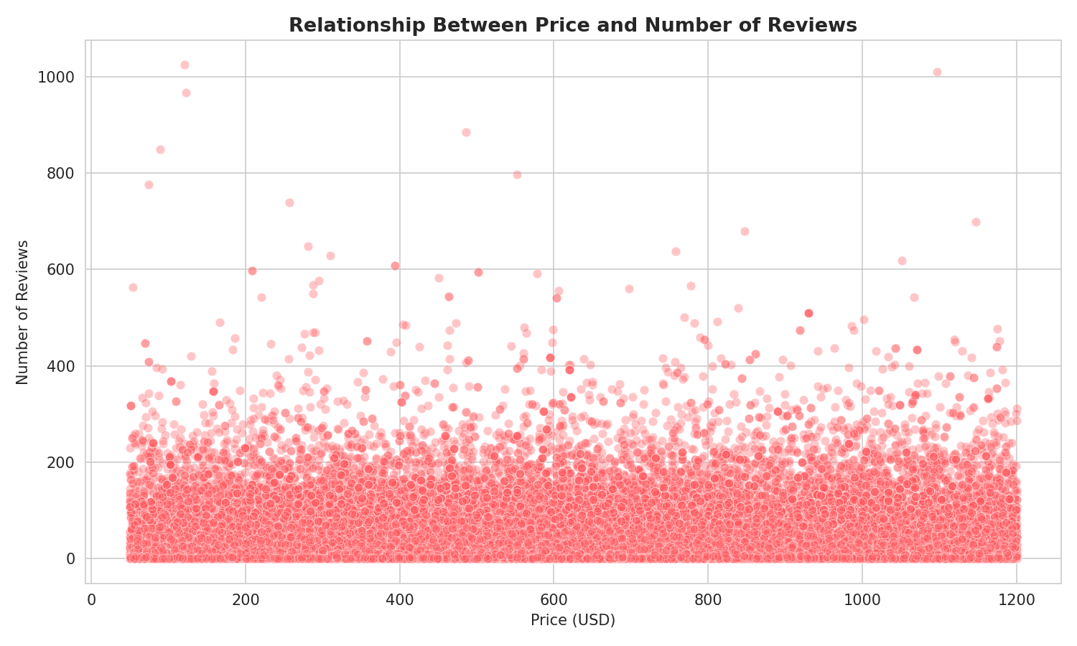
Figure 7: Scatter plot of price against number of reviews
No clear linear relationship is visible between price and number of reviews — highly-reviewed listings exist across the full price range, and this is confirmed quantitatively in the correlation analysis below.
- Correlation Matrix of Numerical Variables
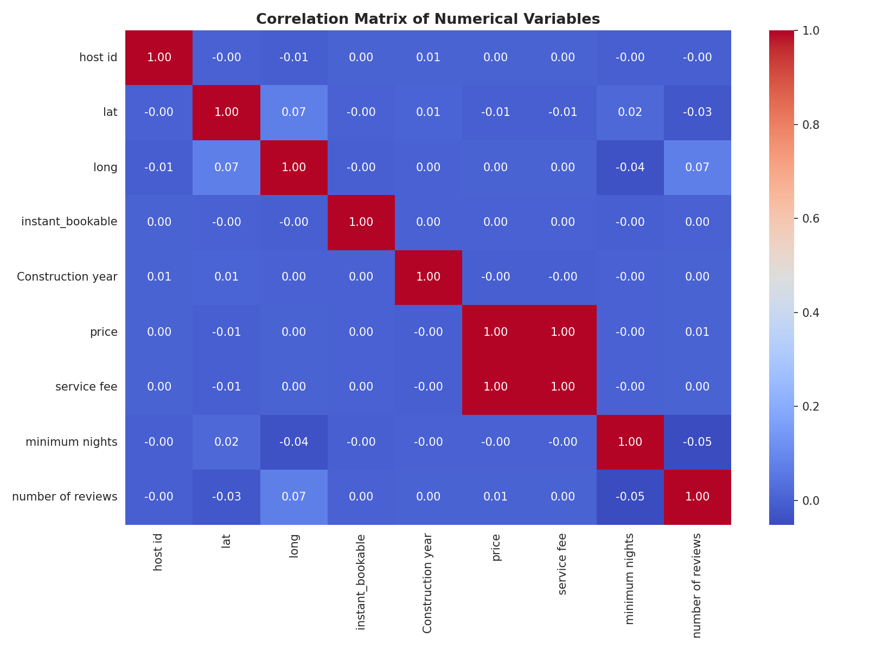
Figure 8: Correlation heatmap of numerical variables
All correlation coefficients among price, service fee, minimum nights, and number of reviews are close to zero (typically between −0.04 and 0.02), indicating that these variables are largely independent of one another in this dataset — price does not meaningfully predict review counts, minimum nights, or vice versa.
- Cancellation Policy Analysis
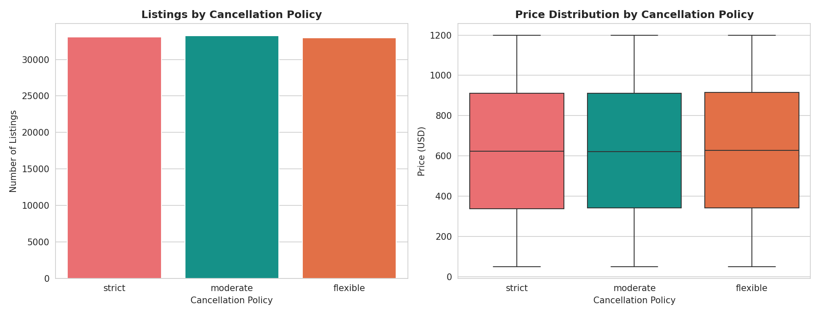
Figure 9: Listings by cancellation policy (left) and price distribution by cancellation policy (right)
The three cancellation policies (moderate, strict, flexible) are nearly equally represented, and median/average prices show negligible variation across policy types, suggesting hosts do not systematically price listings differently based on cancellation flexibility.

Group-Wise Summary Analysis
- Summary by Room Type
Room Type | Listings | Avg. Price | Median Price | Avg. Reviews
Hotel room | 108 | $657.95 | $630.50 | 82.81
Shared room | 2,157 | $635.19 | $655.00 | 20.27
Entire home/apt | 52,047 | $625.35 | $624.00 | 27.23
Private room | 45,018 | $625.07 | $623.00 | 27.73

Hotel room listings, despite being the smallest category by count, show by far the highest average number of reviews (82.81), suggesting these listings turn over guests more frequently or have been active on the platform longer.
- Summary by Neighbourhood Group
Neighbourhood Group | Listings | Avg. Price | Median Price | Avg. Reviews | Avg. Min. Nights
Queens | 12,867 | $629.84 | $627.00 | 33.90 | 6.46
Bronx | 2,627 | $627.62 | $633.00 | 31.71 | 5.41
Brooklyn | 40,525 | $626.49 | $626.00 | 28.40 | 7.25
Staten Island | 920 | $623.10 | $624.50 | 35.09 | 5.88
Manhattan | 42,391 | $623.09 | $622.00 | 23.96 | 9.61

Interestingly, Manhattan — the borough with the most listings — has both the lowest average price and the lowest average number of reviews among all boroughs, while requiring the highest average minimum stay (9.61 nights), a combination that may reflect a more competitive, higher-turnover rental market.
- Average Price by Room Type × Neighbourhood Group (Pivot Table)
Neighbourhood Group | Entire home/apt | Hotel room | Private room | Shared room
Bronx | $620.70 | — | $634.89 | $589.42
Brooklyn | $627.00 | $650.00 | $625.63 | $634.83
Manhattan | $623.76 | $677.59 | $620.91 | $636.82
Queens | $626.19 | $433.25 | $631.86 | $643.24
Staten Island | $643.29 | — | $599.45 | $709.86

This pivot table reveals more meaningful variation than the borough or room-type averages alone: hotel rooms in Manhattan average $677.59 — the highest combination in the table — while hotel rooms in Queens average just $433.25, the lowest, showing that the interaction between location and room type matters more than either factor in isolation.

Key Insights
Entire homes/apartments and private rooms dominate the New York City Airbnb market, together representing over 97% of all listings.
Manhattan and Brooklyn account for more than 83% of listings, consistent with their status as the city's primary short-term rental hubs.
Price is distributed relatively evenly across its $50–$1,200 range and shows very weak correlation with number of reviews, minimum nights, or service fee — no single numerical variable strongly predicts price in this dataset.
Minimum nights and number of reviews are both strongly right-skewed, with small subsets of outlier listings (extended minimum stays up to 5,645 nights; highly-reviewed listings) pulling the mean well above the median in both cases.
Manhattan listings have the lowest average price and fewest average reviews of any borough, despite having the most listings and the highest minimum-night requirement — a pattern worth further investigation in later weeks.
Cancellation policy and host verification status are both nearly evenly split across their categories and show minimal association with price.
The room type × neighbourhood group pivot table shows that meaningful price variation emerges only when location and room type are considered jointly, not individually — e.g., hotel rooms range from $433 (Queens) to $678 (Manhattan).

Challenges Faced and How They Were Overcome
- Currency-Formatted Service Fee Field
Challenge: Although the Week 1 cleaning process converted the price column to a clean numeric type, the service fee column was still stored as text with a "$" symbol and trailing whitespace, preventing it from being used in any numerical summary or correlation analysis.
Resolution: The same string-cleaning approach used for price in Week 1 (stripping the currency symbol and whitespace, then casting to float) was reapplied to service fee, after which its dtype was confirmed as float64 and it was successfully included in the descriptive statistics and correlation matrix.
- Logically Invalid Negative Values
Challenge: The minimum nights column, though free of missing values, contained 12 rows with negative values (as low as −1223), which are not logically possible for a minimum booking duration and would have distorted the mean, histogram shape, and any downstream correlation involving this variable.
Resolution: Rows with negative minimum nights were identified using a boolean filter and removed from the analysis copy of the dataset (eda_df), reducing the working dataset from 99,342 to 99,330 rows. This was documented explicitly as a data-quality correction specific to the EDA stage, distinct from the missing-value handling already performed in Week 1.
- Residual Categorical Typo
Challenge: The neighbourhood group column contained one row with the value "brookln" — a misspelling of "Brooklyn" — that had survived Week 1's automated cleaning steps because it was not a missing value, duplicate, or type-mismatch, but a valid-looking (yet incorrect) text entry.
Resolution: The value was corrected using a direct category replacement (replace({'brookln': 'Brooklyn'})), after which the neighbourhood group column contained exactly five valid categories. This reinforced the importance of manually reviewing value_counts() output for free-text or manually-entered categorical fields, since such errors are invisible to standard null/duplicate checks.
- Right-Skewed Distributions Affecting Visualization Clarity
Challenge: Both minimum nights (max 5,645) and number of reviews contained extreme outlier values that, when plotted on a standard histogram, compressed the bulk of the data into a small number of bins near zero, making the distribution difficult to interpret visually.
Resolution: The histograms were retained in their original scale (rather than being artificially clipped or log-transformed) so as not to misrepresent the presence of real outliers, and the interpretation text explicitly called out the mean-median gap as quantitative evidence of the skew, complementing the visual pattern. Outlier treatment using IQR-based filtering was noted as a planned next step for later weeks rather than being applied here, to keep this week's scope focused on exploration rather than transformation.
- Weak Correlations Complicating Insight Generation
Challenge: Initial expectations going into the correlation analysis were that price would show a meaningful relationship with at least one other numerical variable (such as number of reviews or minimum nights); the near-zero correlation coefficients across the board made it harder to draw a single headline insight from this part of the analysis.
Resolution: Rather than overstating a relationship that the data did not support, the report documents the weak correlations as a genuine finding in their own right — namely, that simple numerical relationships do not explain pricing in this dataset, and that categorical/interaction effects (as seen in the room type × neighbourhood pivot table) are more informative, which is itself a valid and useful EDA conclusion.

Conclusion
This Week 2 internship task provided hands-on experience in exploratory data analysis and visualization, building directly on the cleaned Airbnb dataset produced in Week 1. Working with pandas, Matplotlib, and Seaborn, the analysis moved through statistical summarization, univariate and bivariate visualization, correlation analysis, and group-wise aggregation to build a comprehensive picture of the New York City Airbnb listings dataset.
The process also surfaced additional, more subtle data quality issues — a text-formatted currency field, invalid negative values, and a residual categorical typo — that had not been caught during Week 1's cleaning pass, reinforcing that data cleaning and exploratory analysis are iterative, complementary processes rather than strictly sequential ones. Twelve annotated visualizations were produced covering distribution, comparison, relationship, and correlation analysis, each interpreted in the context of the underlying business question of what drives Airbnb listing characteristics in New York City.
Overall, this task strengthened practical proficiency in statistical and visual data exploration using Python, and reinforced the discipline of grounding every insight in the data itself — including reporting weak or absent relationships honestly rather than overstating patterns that the data does not support.
- Key Learnings
Practical application of Seaborn and Matplotlib for count plots, histograms, box plots, scatter plots, and correlation heatmaps.
Techniques for identifying and correcting data quality issues that are only visible once a numerical or statistical lens is applied to the data.
Use of groupby() and pivot_table() for multi-dimensional summary analysis beyond simple column-level statistics.
The importance of interpreting each visualization in writing, not just presenting the chart, to convert raw patterns into actionable insight.
Recognizing and reporting weak or near-zero correlations as legitimate, useful findings rather than a lack of results.
- Future Scope
Building on this EDA, subsequent weeks of the internship are expected to involve outlier treatment (e.g., IQR-based filtering of the minimum nights column), feature engineering from location and review data, and predictive modeling of listing price using room type, neighbourhood group, and host attributes as inputs, informed directly by the patterns and relationships (and non-relationships) identified in this report.

References
- Cleaned_Data.csv — output of the Week 1 Data Acquisition, Cleaning, and Preprocessing task.
- pandas documentation — https://pandas.pydata.org/docs/
- Seaborn documentation — https://seaborn.pydata.org/
- Matplotlib documentation — https://matplotlib.org/stable/index.html
- Yuva Intern / National Skill Development Corporation (NSDC) — Week 2 Task Brief: Exploratory Data Analysis and Visualization.

